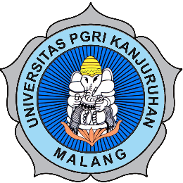 |  | Partner’s logo

MEMORANDUM OF UNDERSTANDING

Between

Universitas PGRI Kanjuruhan Malang
Republic of Indonesia
And
Partner’s Institution
Country

Wherein Universitas PGRI Kanjuruhan Malang (UNIKAMA) represented by its Rector, Dr. Sudi Dul Aji, M.Si. acting under the charter, and Partner’s Institution (INITIAL) represented by its Position, Name (hereafter referred to as both parties) recognize the need for and benefits of increased cooperation and communication within the international community of universities, and:

Wherein both parties agree that it is desirable to establish between them a relationship which will encourage such cooperation and communication, and:

Wherein both parties desire to ensure that such a relationship will be mutually beneficial.

IT IS HEREBY AGREED as follows:

1 Both parties shall encourage the following activities to expand and promote their mutual interests:

- Exchange of students,
- Exchange of faculty members,
- Joint development, promotion, and information of academic publications and conferences,
- Development of collaborative research, and
- Development of collaborative community services.

2 Both parties agree that financial arrangements are not subject to this agreement. Should any financial responsibilities arise, they shall be settled in a separate agreement.

3 This agreement shall come into effect upon the signature of the designated signatories of both institutions in English and may be renewed every five years upon the mutual consent of both parties.

In witness whereof, the parties hereto have signed

On behalf of | On behalf of
Universitas PGRI Kanjuruhan Malang | Partner’s Institution
_________________________ | _________________________
Dr. Sudi Dul Aji, M.Si | Name
Rector | Position
Date: ………………………….. | Date: …………………………..

